SECTION A. (40 MARKS)
- Give the type of energy possessed by a rolling stone.
_____________________________________________________________________
- In which one way is the heat transfer by conduction beneficial to humans?
_____________________________________________________________________
- Name the method of soil formation where large rocks break into tiny particles.
_____________________________________________________________________
- Why does blood go to the kidney during circulation?
_____________________________________________________________________
- State any one difference between the life cycle of a cockroach and a housefly.
__________________________________________________________________________________________________________________________________________
- Apart from memory cards and discs, mention any one other device used in storing sound.
_____________________________________________________________________
- What is the role of a drone bee in a bee hive?
_____________________________________________________________________
- Give the function of ventilators in a house.
_____________________________________________________________________
- Which domestic animals suffer from the ear canker disease?
_____________________________________________________________________
- In which one way are animals important during photosynthesis?
_____________________________________________________________________
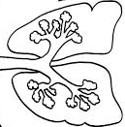
The diagram below shows the structure of the lungs . Use it to answer questions 11 and 12.
Q

- Give the function of the part marked Q.
_____________________________________________________________________
- Show with an arrow and letter P the bronchus.
- Why is maize said to be a fruit but not a seed?
__________________________________________________________________________________________________________________________________________
- Which type of movable joint allows movement in all directions?
_____________________________________________________________________
- Give any one characteristic of seeds dispersed by wind?
_____________________________________________________________________
- State one reason why a bird that sits on live wire of electricity does not get killed?
_____________________________________________________________________
- Which structure in spiders does the same function as spiracles in insects?
_____________________________________________________________________
- Which blood group is referred to as universal donor?
_____________________________________________________________________
- Name the element of Primary Health Care which looks after mothers and their children’s health.
_____________________________________________________________________
- Give one example of a renewable energy resource.
_____________________________________________________________________
- To which class of lever does a bottle opener belong?
_____________________________________________________________________
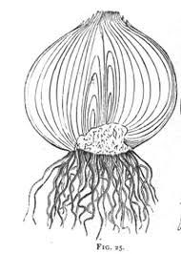
The diagram below shows a section through a bulb of an onion. Use it to answer questions 22 and 23.
R

T

- Name the part marked T.
_____________________________________________________________________
- Give the function of part R to the plant.
_____________________________________________________________________

- State one reason why a green object appears green.
_____________________________________________________________________
- Why is Louis Pasteur remembered in the study of bacteria?
_____________________________________________________________________
- Name the waste product excreted through the skin?
_____________________________________________________________________
- How does a cassava plant obtain its food when its leaves have fallen off?
_____________________________________________________________________
- What happens to a permanent magnet when it is left in a hot charcoal for a long time?
_____________________________________________________________________
- What instrument is used to measure electric current?
_____________________________________________________________________
- Calculate the mechanical advantage of a wheel barrow which carried a load of 80 kg using an effort of 20N.

- Write down any one problem associated with sex deviation.
_____________________________________________________________________
- Give one way in which farmers can control foot and mouth diseases in cattle.
_____________________________________________________________________
- What feature on the body of a housefly enables it to spread germs easily?
_____________________________________________________________________
- What are essential drugs?
_____________________________________________________________________
- Which part of air is used in fire extinguishers?
_____________________________________________________________________
- What name is given to animals that feed on dead decomposing organisms?
_____________________________________________________________________
- Apart from lung cancer, name any one other disease caused by smoking cigarette.
_____________________________________________________________________
- Write a simple food chain involving the following organisms in the space provide below: snakes, plants, Lizards and insects.
_____________________________________________________________________
- Name the class of food which is acted upon by the enzyme lipase in the human digestive system.
_____________________________________________________________________
- How do amoeba reproduce?
_____________________________________________________________________
SECTION B.
- The diagrams below show the effect of different materials on light. Use it to answer the questions that follow.

Torch
Torch
Torch
A
B
C

- Name the type of materials labeled A, B and C.
- A ____________________________________________________________
- B ____________________________________________________________
- C ____________________________________________________________
- Give any one example of materials represented in C.
________________________________________________________________
- (a) Name any two body organs responsible for excretion in humans.
(i) __________________________________________________________________
(ii)__________________________________________________________________

- (a) What part of the eye regulates the amount of light entering the eye?
_____________________________________________________________________
(b) What term is used to describe the ability of the eye to alter its focal length in order to focus objects?
_____________________________________________________________________
(c)The diagrams below show how the size of the pupil is regulated in different light intensities.

A
B

Which of the diagrams above show the size of the pupil in:
- dim light ______________________________________________________
- bright light _____________________________________________________
- (a) What does the term infant mortality mean?
__________________________________________________________________________________________________________________________________________
(b) Give three ways in which infant mortality can be reduced in Uganda.
(i)___________________________________________________________________
(ii)__________________________________________________________________
(iii)__________________________________________________________________

- (a) State any two reasons why friction is a nuisance force.
(i)___________________________________________________________________
(ii)__________________________________________________________________
(b) In which two ways is friction an advantage to people?
(i)___________________________________________________________________
(ii)__________________________________________________________________

- Briefly explain how the skin regulates the human body temperature during:
- Hot days.
__________________________________________________________________________________________________________________________________________
- Cold days
__________________________________________________________________________________________________________________________________________
- The table below shows animals in list A and the diseases that affect them in list B.
A B
Dogs new castle disease
Rabbits black quarter
Cattle rabies
Chicken snuffles.
A B
(a) dogs __________________________________
(b) rabbits ___________________________________
(c) cattle ___________________________________
(d) chicken ___________________________________

- State any two methods used to preserve
- Meat
(i)______________________________________________________________
(ii)_____________________________________________________________
- Root-tubers.
(i)______________________________________________________________
(ii)_____________________________________________________________

- (a) Name the garden tool used for transplanting seedlings from a nursery bed to the main garden.
_____________________________________________________________________
(b) Give any three ways in which school gardens are important.
(i)___________________________________________________________________
(ii)__________________________________________________________________
(iii)__________________________________________________________________
- (a) State any two characteristics of mammals.
(i)___________________________________________________________________
(ii)__________________________________________________________________
(b) What term is used to describe mammals that feed on:
(i) Plants _____________________________________________________________
(ii)Meat ______________________________________________________________
- (a) Name the two childhood killer diseases against which children are immunized at birth.
(i)___________________________________________________________________
(ii)__________________________________________________________________
(b) Which vaccine is administered to adolescent girls and women up to about 45 years of age?
_____________________________________________________________________
- State any one way in which school pupils can participate in the campaign against childhood immunizable diseases.
_____________________________________________________________________

- (a) Give the meaning of each of the following words as used in sound
- Pitch __________________________________________________________
- Frequency _____________________________________________________
- Volume ________________________________________________________
(b) How is sound produced?
_________________________________________________________________
- (a) In one sentence describe what is meant by first aid in science.
__________________________________________________________________________________________________________________________________________
(b) Give any three ways in which first aid is important.
(i) __________________________________________________________________
(ii)__________________________________________________________________
(iii)__________________________________________________________________
- The diagram below shows a type of eclipse. Study and use it to answer the questions that follow.
Moon
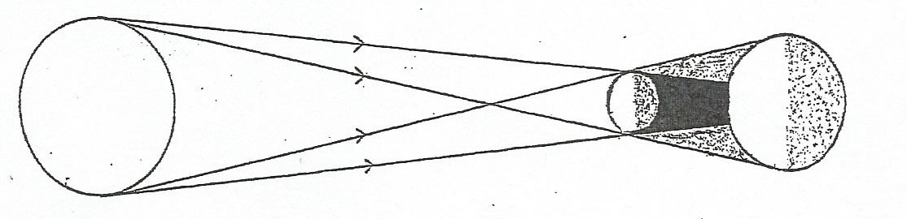
X
Earth
sun

P
Q

- Name the type of eclipse shown in the diagram above.
________________________________________________________________
- Name the shadows marked P and Q.
- P________________________________________________________
- Q _______________________________________________________
- What happens to a person who would be in part X during the eclipse?
________________________________________________________________

END.

